Technology  
Bingo

To complete this challenge, create an aura using Aurasma to use in your classroom.

*i.e. in a station for instructions or to check work.*

Aurasma



Technology  
Bingo

To complete this challenge, create a QR code using  
www.QRstuff.com and use in your classroom.

*i.e. in a station for instructions or to check work*

QR Codes



Technology  
Bingo

To complete this challenge, have students use  
Puppet Pals HD to demonstrate knowledge   
and make their thinking visible.

Puppet Pals HD

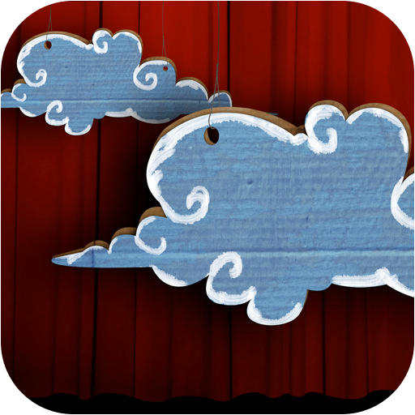

Technology  
Bingo

To complete this challenge, have your students  
use Popplet to create a thinking  
map or graphic organizer.

Popplet



Technology  
Bingo

To complete this challenge, setup your Google Email   
in order to activate Google’s Apps.

Google Email



Technology  
Bingo

To complete this challenge, checkout a school   
iPad cart for your classroom.

iPad Cart



Technology  
Bingo

To complete this challenge, use a Discovery Education video in your classroom to support your content.

Discovery Education



Technology  
Bingo

To complete this challenge, use Brain Pop   
in your classroom.

*i.e. in a station or for content specific introduction or support.*

Brain Pop



Technology  
Bingo

To complete this challenge, use Infuse Learning to connect and poll your classroom during your lesson.

Infuse Learning



Technology  
Bingo

To complete this challenge, have your students shoot, edit and create a movie using iMovie.

*i.e. a project presentation, an assessment of knowledge, etc.*

iMovie



Technology  
Bingo

To complete this challenge, use Google Hangouts to connect to another classroom.

Google Hangouts



Technology  
Bingo

To complete this challenge, use any Google App to create something that your team can use to  
collaborate on Google Drive.

Collaborate!



Technology  
Bingo

To complete this challenge, have your students edit  
a picture using Skitch adding labels or  
descriptions to the picture.

Skitch



Technology  
Bingo

Update Your Website

To complete this challenge, simply update   
your school webpage.

\**Consider adding content from this challenge to your page.*

Technology  
Bingo

To complete this challenge, create an account, then create a screencast AND have a student create a screencast using the Show Me app.

*i.e. a concept tutorial, a reteaching, a presentation report, etc.*

Show Me

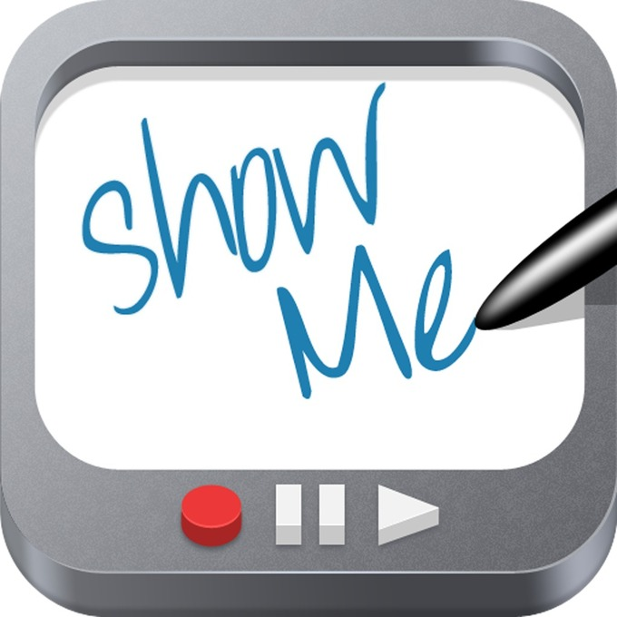

Technology  
Bingo

To complete this challenge, send a tweet from your account to @yourname on Twitter.

Tweet @yourschool



Technology  
Bingo

To complete this challenge, follow  
@yourschool on Twitter

Follow @yourschool



Technology  
Bingo

To complete this challenge, create a Google Form and have your students complete it.

*i.e. a survey, an informal quiz, etc.*

Google Forms



To complete this challenge, create a Google Doc and share it with your teammates.

Google Docs



Technology  
Bingo

Technology  
Bingo

To complete this challenge use Google Sheets to create a spreadsheet for use in your classroom.

*i.e. grade tracker, assignment tracking, station tracking, etc.*

Google Sheets



To complete this challenge, create a presentation in Google Slides for your classroom.

Google Slides



Technology  
Bingo

Technology  
Bingo

To complete this challenge, begin using your your Google Drive account and save files to Drive.

*Just drag and drop files into your drive by*

*visiting drive.google.com on your computer.*

Google Drive

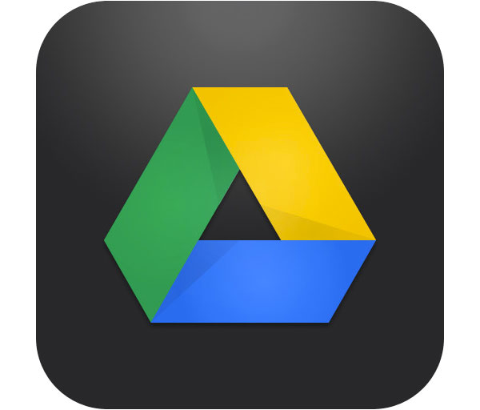

To complete this challenge you must add your classes to Class Dojo and track points with your students.

*Print a report from Class Dojo for proof of completion.*

Class Dojo



Technology  
Bingo

Technology  
Bingo

To complete this challenge your students need to create a video using the app Explain Everything.

*i.e. concept tutorial, reading report, research report, station example*

Explain Everything



To complete this challenge you must join Twitter.

Join Twitter!



Technology  
Bingo